StudentHub Portal
PHP Server-Side Form Processing
Implementation Report

1. Files Created & Modified

New Files Created:
File Path | Type | Purpose
php/process_registration.php | PHP | Validates & stores registration data
php/process_contact.php | PHP | Validates & stores contact messages

Existing Files Modified:
File | Change Made
pages/register.html | form action → "../php/process_registration.php"
register.html | form action → "php/process_registration.php"
pages/contact.html | form action → "../php/process_contact.php"

Output Data Files (auto-created on first submission):
File | Format
data/registrations.json | JSON
data/registrations.csv | CSV
data/contact_messages.json | JSON
data/contact_messages.csv | CSV

2. Registration Form — PHP Processing

2.1 Registration Form (HTML)
The registration form collects: Full Name, Email, Mobile, Gender, Course, Academic Year, Password, Confirm Password, and Terms acceptance. The form's action attribute now points to process_registration.php.
Output Screenshot:
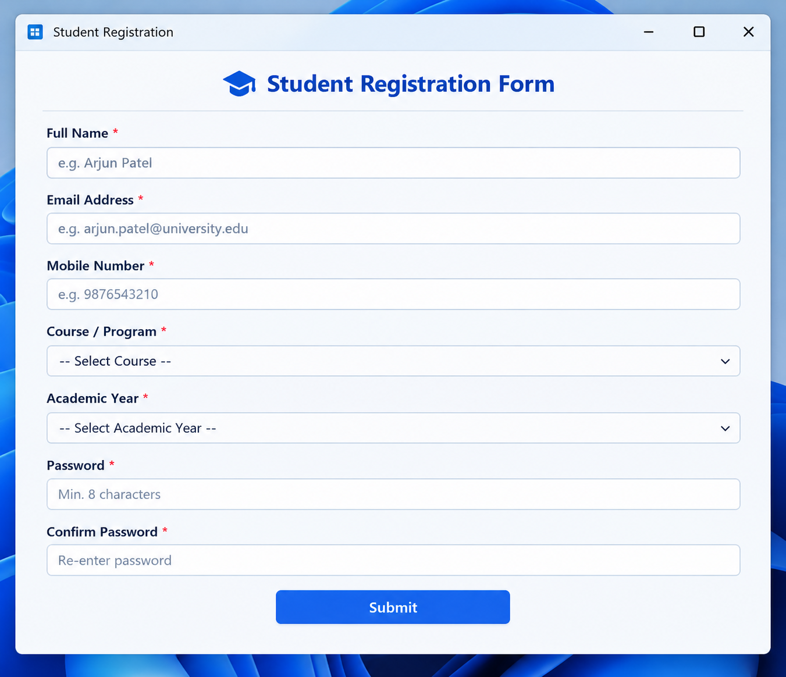

2.2 Server-Side Validation Rules
Field | Validation Rule | PHP Function Used
Full Name | Alphabets & spaces, 3-50 chars | preg_match(), htmlspecialchars()
Email | Valid email format | filter_var(FILTER_VALIDATE_EMAIL)
Mobile | 10 digits, starts with 6-9 | preg_match(), preg_replace()
Gender | Must be Male/Female/Other | in_array() whitelist
Course | Must match allowed list | in_array() whitelist
Year | Must match allowed list | in_array() whitelist
Password | 8-32 chars, upper+lower+digit+special | preg_match(), password_hash()
Duplicate | Email must be unique | JSON file lookup

2.3 Registration — Success Output
When all validations pass, the student record is saved to both JSON and CSV files. A green success page displays the student's details and assigned ID.
Output Screenshot:
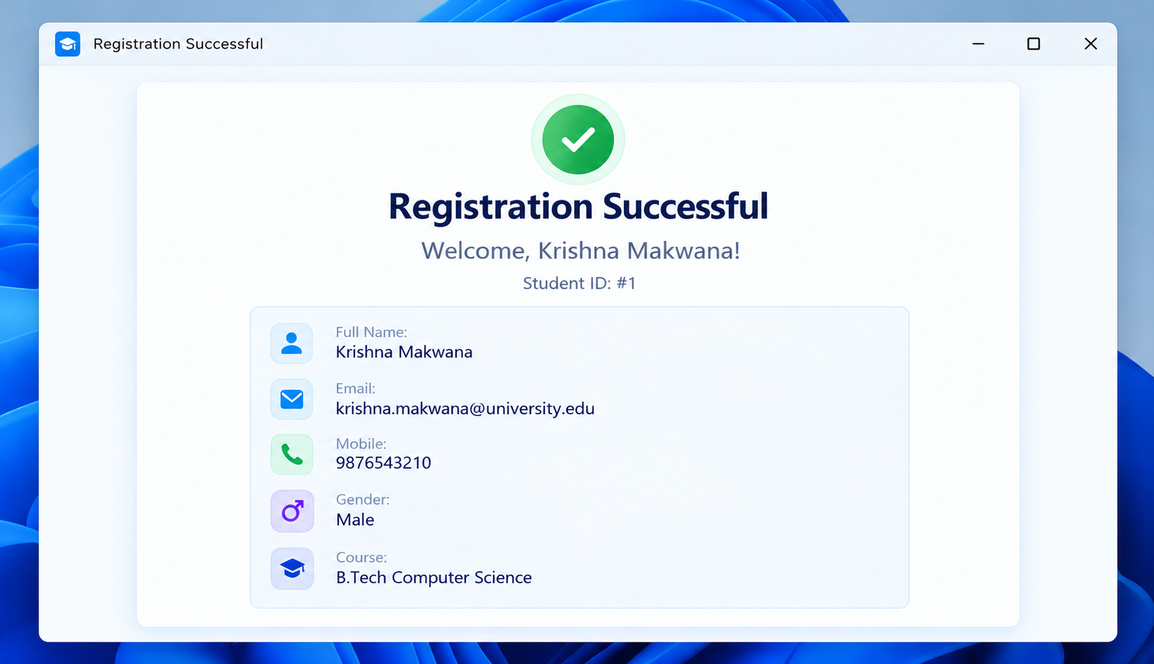

2.4 Registration — Error Output
When validation fails, a red error page shows all validation errors. The user can click 'Go Back & Fix Errors' to return to the form.
Output Screenshot:
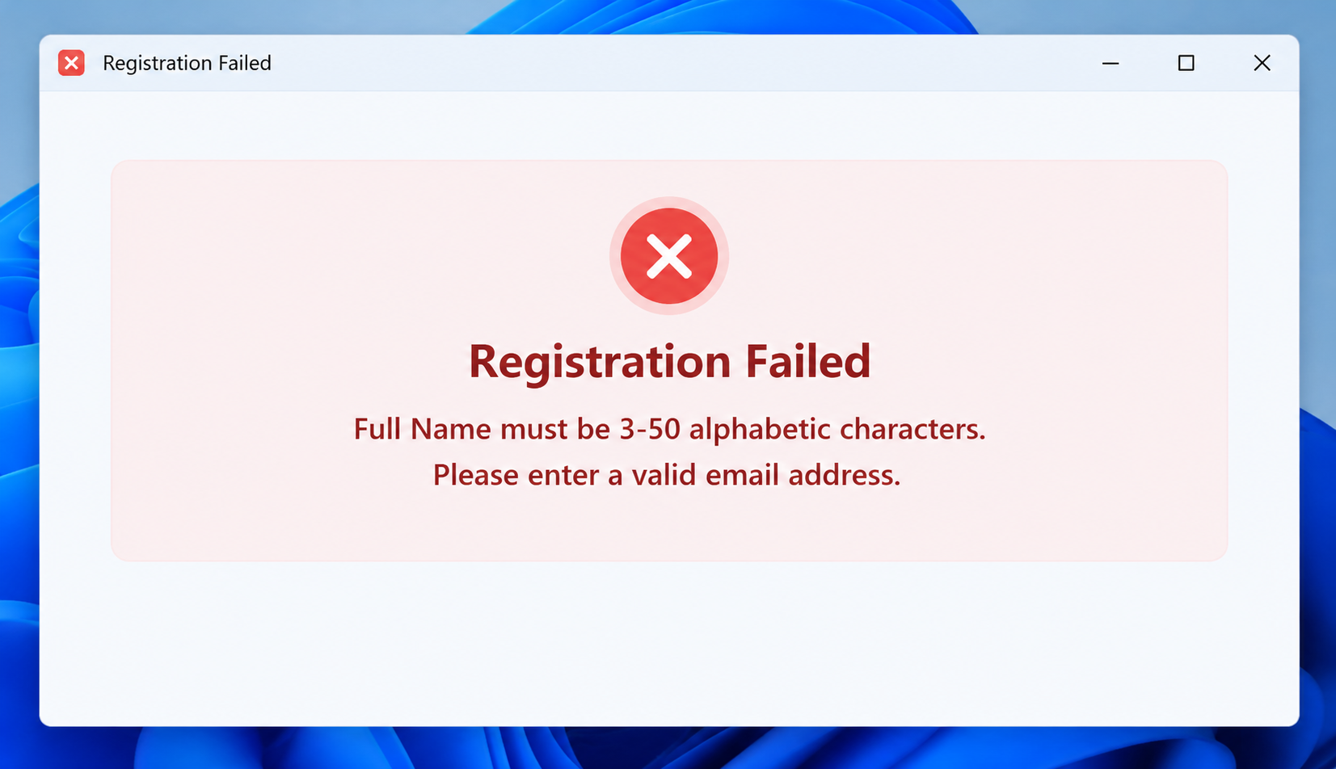

3. Contact Form — PHP Processing

3.1 Contact Form (HTML)
The contact form collects: Full Name, Email, Subject (dropdown), and Message. The form action now points to process_contact.php.
Output Screenshot:
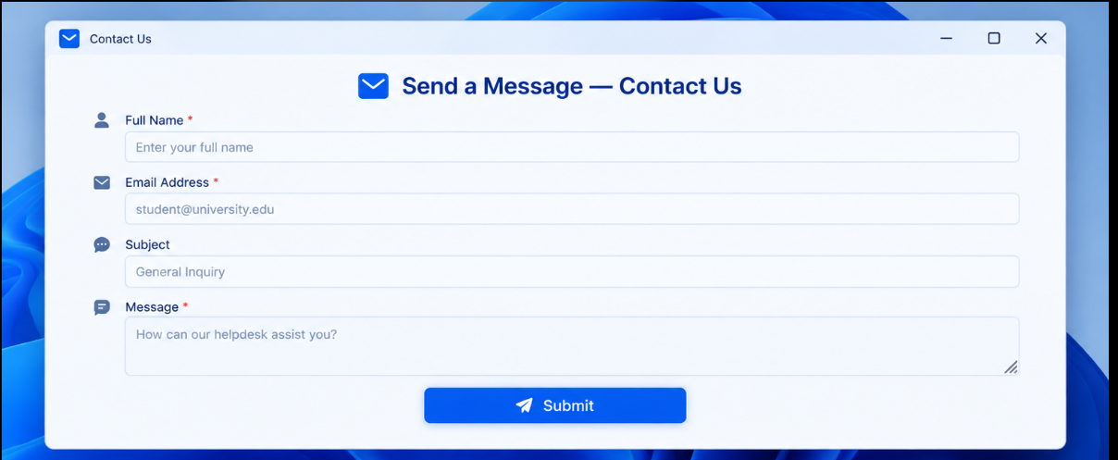

3.2 Contact — Success Output
On successful submission, a ticket number is assigned and the user sees a green confirmation.
Output Screenshot:
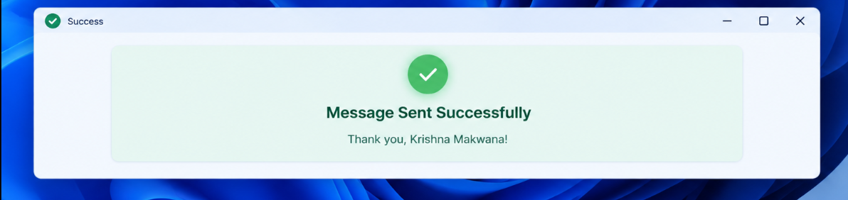

3.3 Contact — Error Output
If validation fails, all errors are listed on a red error page.
Output Screenshot:

4. Data Storage — JSON Files

4.1 registrations.json
Each registration is appended as a JSON object with all fields plus a hashed password and timestamp.
Output Screenshot:
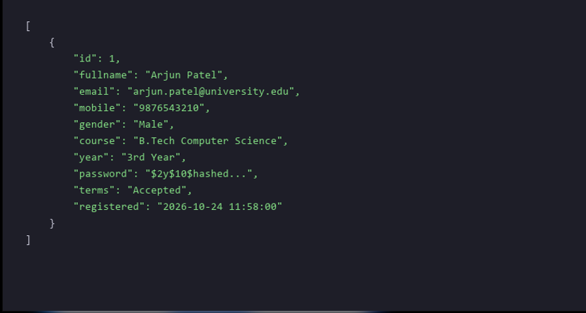

4.2 contact_messages.json
Each contact message is stored with an auto-incremented ID and submission timestamp.
Output Screenshot:
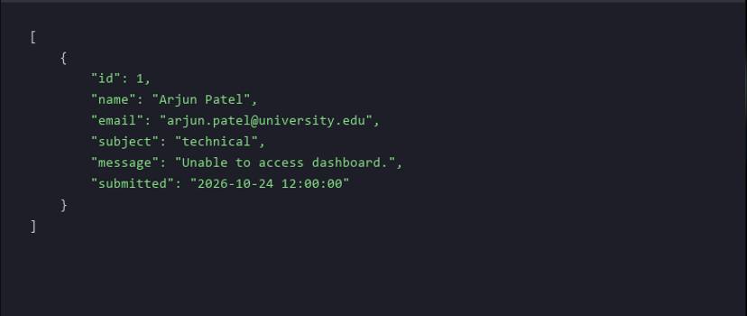

5. Data Storage — CSV Files

5.1 registrations.csv
A header row is written on first submission. Subsequent records are appended as CSV rows.
Output Screenshot:


5.2 contact_messages.csv
Contact messages are stored identically in CSV format.
Output Screenshot:
